Upgrade Kubernetes Cluster Using Kubeadm
Documentation prepared by Tulasi
Followed by this documentation
https://medium.com/@phanindra.sangers/how-to-upgrade-kubernetes-cluster-using-kubeadm-v1-28-v1-29-dd90c1cacd52
Steps :
- Install kubeadm setup with one master node and two worker nodes
Kubectl get nodes
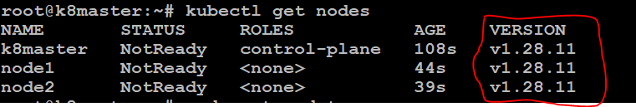
- Update the kubernetes 1.28. → 1.29.
Update master node and same procedure can be followed to update other worker nodes.
- Goto Your master node drain the node, run the following command in your master node.
kubectl drain k8master --ignore-daemonsets
- We can check node got in scheduling disabled.
- Now we need to unhold kubeadm kubelet kubectl
apt-mark unhold kubelet kubeadm kubectl
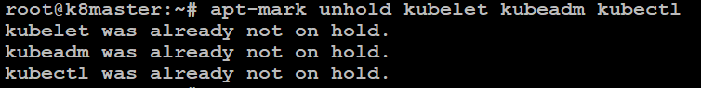
- Since we want to update from 1.28.11 to 1.29.x we need check first what is the kubeadm version and what are kubeadm versions available.
kubeadm version
apt-cache madison kubeadm
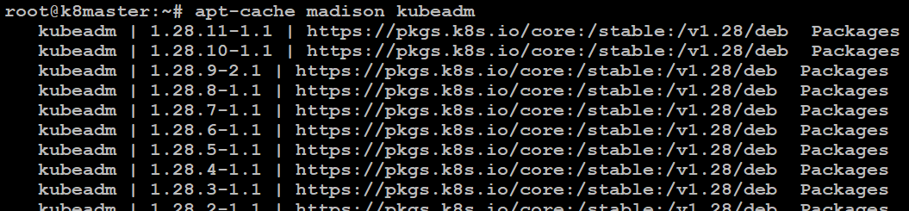
- We can see here we only have 1.28.x version available we need 1.29.x version for that , run this in masternode.
echo 'deb [signed-by=/etc/apt/keyrings/kubernetes-apt-keyring.gpg] https://pkgs.k8s.io/core:/stable:/v1.29/deb/ /' | sudo tee /etc/apt/sources.list.d/kubernetes.list
apt-get update
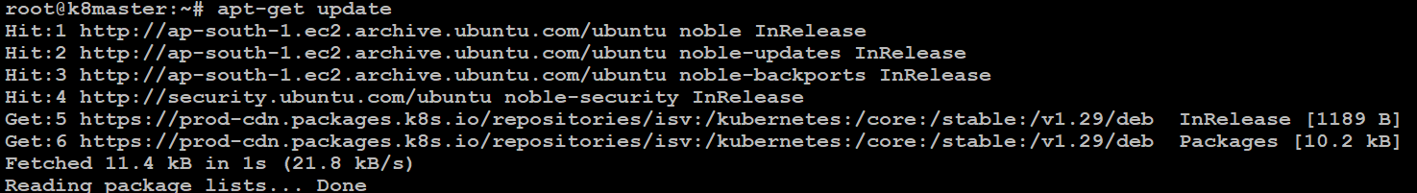
- Now you can see we have 1.29.x versions available.
The latest 1.29.x available is v1.29.2–1.1 so we will provision this.
apt-get install kubeadm=1.29.2-1.1 kubelet=1.29.2-1.1 kubectl=1.29.2-1.1
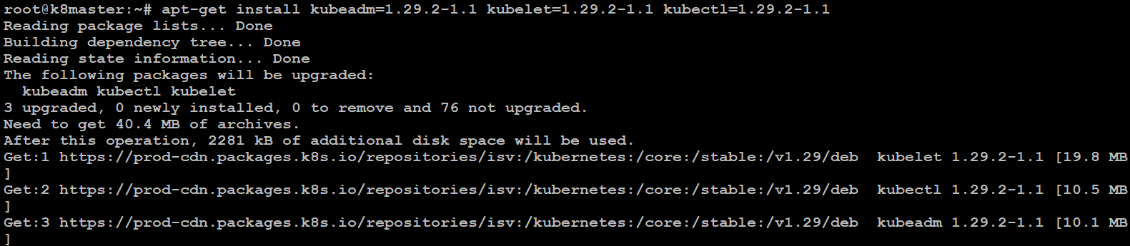
- Apply the version
kubeadm upgrade apply v1.29.2-1.1
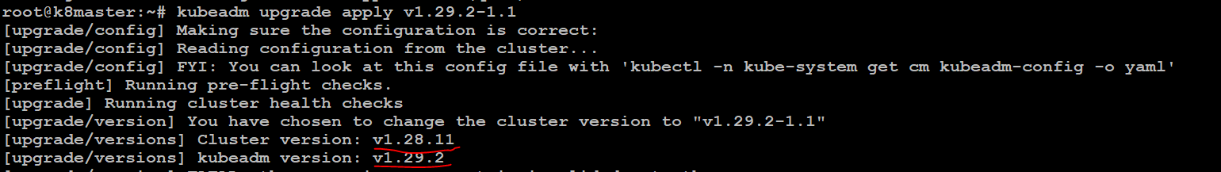
- Restart the kubectl
systemctl restart kubelet
kubeadm version

apt show kubectl
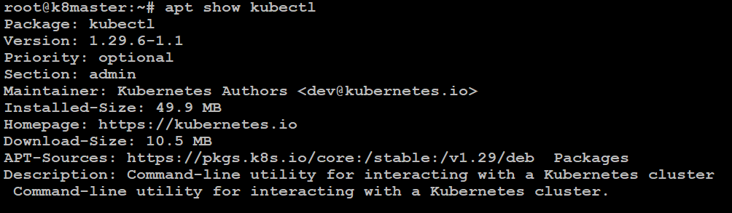
- Follow the all steps into worker nodes also.
- You can check master node got updates to 1.29.2
kubectl get nodes
